**Tutorial**

The tutorial contains two distinct parts: an “onboard” part that deals with non-combat procedures and a “on world” part, that introduces combat.

**In part** 1: Introduces the player to the main game mechanics on the ship using the mysterious AI.

* **Room 1**:
  + You are shown to be put together by a massive machine before getting up and walking out of it and revealing to be in a small room with a singular door
  + The overheard AI tells him that there are items in the room in which explains his purpose. He must collect them and then open the door. (*The door won’t open if the player doesn’t complete the two objectives things.)*
  + After that, the player must complete three things:
    - There will be a book item on a table on the right side of the door. This allows the player to figure out that there will be book items and teaches them to pick it up. This book has his mission parameters and activates the Hud.
    - There are also two weapons on another longer table to the left side of the door. This allows the player to pick up weapons for the first time and learn how to equip them.
  + Lastly is a door which can only be opened if the two objectives are completed. Once those are completed, the door with have a pop up when approached, telling the player the control to open it.
* **Main Hub Room**:

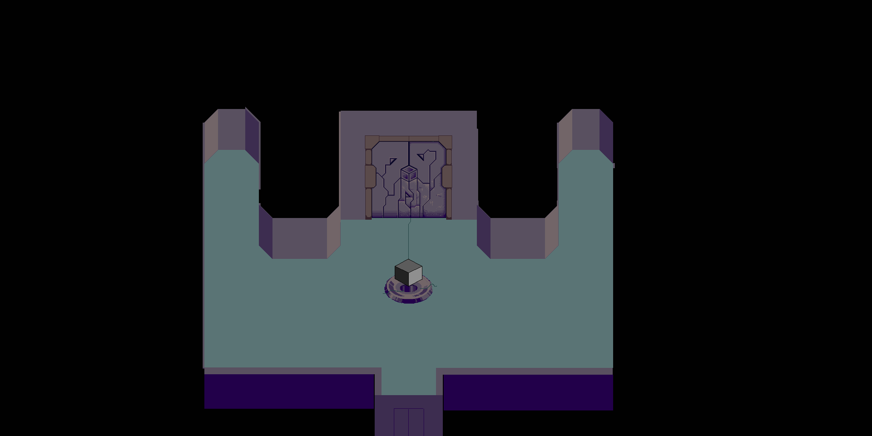



* In this main room, which is the main hub room for the rest of the game, you’ll find the pedestal for the cube pieces(C), the end game boss door(B), the respawn chamber(D) and the ground world teleporter(A).
* The player cannot teleport to the world until they have looked at each of the other three items.
* Once they have talked to them, the world teleporter will light up and the player can move to the second part of the dungeon.

**In part 2**: Introduces the player to the combat system. This includes:

* How to attack
* Health and shields
* Weapons
* Enemies

Each Dungeon has an empty "Start" room that served as a moment and an intro to the dungeon theme. It also allows for the player to fool around with their gear and prepare before starting the dungeon.

The first dungeon will have this room contain your first shield and allow you to pick it up and learn it's mechanics.

* Once you have activated the shield, the door to the dungeon will open.
  + This teaches the shield and gates that info, while also teaching the dungeon door mechanic.

After you have entered the second room in the first dungeon, there will be one regular enemy that you must kill, you must clear a room before you can continue. Once this enemy is killed, you can move on.

* This teaches the killing and room clearing mechanics.

Lastly if you take health damage or die, both mechanics will have visual feedback to the player

***Why is this interesting?***

It’s transitioning between environments and its quick. It doesn’t bog down the player immediately with an insane amount of instructions but rather just teaches them as the player is presented with them. That’s why the combat isn’t taught until after the player has reached the planet. They don’t need combat in the ship, so why teach it there.